STAT 4011

Project 1

Prediction of Vehicle Carbon Dioxide Emissions by Statistical Learning Models



Group 1
CHAN Hoi Ching 1155125751
CHAN Kwan Yue 1155144322
LAM Kaysha 1155112312
LAU Ka Keung 1155142681
LEUNG Wan Hoi 1155142877
TSANG Chor Ki 1155143026

- Introduction
As hotter summers and warmer winters become a common phenomenon, environmental protection has gained increasing global importance. Road transportation-related contamination, particularly from vehicles, is a main contributor to environmental deterioration. To reduce its impacts, characteristics of light-duty vehicles are identified to build a CO2 emissions prediction model.
The audience is assumed to have interest in statistics and machine learning, an application of artificial intelligence enabling systems to learn from experience without explicit programming. No prior knowledge is required.
The dataset consists of model-specific fuel consumption ratings and estimated carbon dioxide emissions for new light-duty vehicles for retail sale in Canada. Vehicle manufacturers use controlled experimental procedures to generate fuel consumption data. Afterwards, Environment and Climate Change Canada and Natural Resources Canada collates information to publish the Fuel Consumption Guide for audiences including car purchasers, manufacturers, and government bodies.
The aim of this paper is to shortlist a machine learning algorithm with the greatest predictive power of carbon dioxide emissions based on critical features, such that consumers can compare and purchase vehicles with longer lifetime and lower maintenance costs, saving money in the long run.

- Data
The data used spans 7 years of compiled features and CO2 emissions of various light-duty vehicles. There are 7385 rows of observations and 12 columns in total. The columns include 11 features: Make, Model, Vehicle Class, Engine Size, Cylinders, Transmission, Fuel Type, Fuel Consumption City, Fuel Consumption Hwy, Fuel Consumption Comb (L/100 km), Fuel Consumption Comb (mpg), and 1 target variable: CO2 emissions. With a large sample size to features ratio, dimension reduction is not necessary. There are 5 non-numeric features which require further analysis to see if it can be manipulated or may otherwise be dropped. There are no null or missing values.

Data Visualization
As part of the data exploration, distributions and interactions of discrete and continuous variables and a correlation matrix is plotted and shown in the Appendix. Some notable insights:
- The top company is Ford
- Suv-small is the most common vehicle class
- Majority of vehicles have 8-16L/100km fuel consumption
- All features have a strong positive correlation with CO2 Emissions except for Fuel Consumption Combined which has a strong negative correlation with it
- Median engine size is 3L, while the mode is 2L. Usually, a larger engine is more powerful, accelerates faster, and has a higher speed, but it may burn more fuel and emit more CO2
- Data is centralized on 3 to 8 cylinders. The more cylinders, the less the horsepower and carbon emissions
- Regular (49%) and premium (43%) gasoline make up overwhelming majority of the data
- Strong positive relationship between Fuel Consumption Comb and CO2 Emission, though the data is split by two different slopes due to fuel type. Vehicles using ethanol emit less CO2

Data Preprocessing
Since linear regression and XGBoost require numerical values, one hot encoding is used to replace 5 categorical variables with 93 dummy variables. The “Model” column is dropped since there are 2053 unique values out of 7385. It would not provide much information besides the values in “Make” and would result in an overly complex model. Additionally, normalization is applied to avoid distortion of differences in range and to model the data accurately for linear regression and KNN. The new dataframe is shown in the Appendix.

- Methodology
Models
Six algorithms are employed and compared to select one in terms of predictive power.
- Linear, Lasso, Ridge Regression
Linear regression is a simple and popular baseline model to evaluate the performances of more complex models. A linear relationship is assumed between input variables x and an output variable y. However, the model is not penalized for choice of weights. In order to prevent overfitting, two modifications, namely lasso, which penalizes the model for the sum of absolute values of the weights, and ridge, which penalizes for the sum of squared value of the weights, are used.
- K-Nearest Neighbors Algorithm
KNN is a supervised nonlinear learning algorithm. It provides an alternative if the true relationship is nonlinear and is also easy to interpret and scale to big data.The prediction of a new data point is the average of the k nearest data points’ response variable. “Nearest” is defined by Euclidean distance, which is the length of the difference of two vectors.
- Extreme Gradient Boosting
XGBoost, or Extreme Gradient Boosting, is an ensemble method that aims to aggregate weak learning models to form a stronger and more robust estimator (Zhang et al., 2018). At each iteration, the residual of the previous estimator is used to learn and optimize the loss function. A binary decision tree is selected as a basic learner, and regularization added to avoid overfitting. Extreme refers to pushing computational limits to achieve gains in accuracy and speed.
- Random Forest
Random forest is powerful and accurate on a variety of problems, including features with nonlinear relationships. It is constructed of numerous individual decision trees that run independently to represent a feature class prediction. Each tree gives a predicted value and the forest averages all predictions as output as an ensemble.
All hyperparameters (except in linear regression) are currently following the default setting.

Performance Metrics
Three metrics are used to consistently evaluate and compare model performance.
Root-mean-square error =
Mean absolute percentage error =
Mean absolute error =
10-fold cross validation is used to evaluate and compare model results. For each fold, 70% is used as a training set while the remaining 30% is used as a test set.

- Analysis
Comparison of Algorithms
 | Linear Regression | Lasso | Ridge | KNN | XGBoost | Random Forest
RMSE | 5.3224 | 9.3545 | 5.302839 | 5.9344 | 3.5362 | 3.9224
MAPE (%) | 2.9943 | 5.9765 | 3.011799 | 1.3808 | 0.9388 | 0.8339
MAE | 1.2191 | 2.346942 | 1.221484 | 3.5064 | 2.3333 | 2.0493
Random forest has the best performance in terms of MAPE and MAE, whereas XGBoost performs best by RMSE. Hence, we will proceed with random forest as our prediction model.

Parameter Tuning
Hyperparameters are tuned to improve performance. GridSearchCV finds optimal parameters within a given range. Max_depth refers to maximum tree depth and balances local learning and overfitting. Max_features is the maximum number of features to consider at each split. N_estimators is the number of trees in the forest to average over. A higher number will improve but slow down performance. The best result is achieved by max_depth = 19, max_estimators = 9, n_estimators = 125.

- Results
Random forest was the most accurate among six models. As shown in the Appendix, after parameter tuning of max_depth, max_estimators, and n_estimators, the performance has deteriorated. Hence, it is suggested to use the default hyperparameters or test other parameter sets for tuning.
In terms of feature importance, combined fuel consumption (55% city + 45% highway) is the most relevant variable to accurately predicting CO2 emissions, and to a lesser extent engine size. This is expected as the more fuel required to travel a given distance, the more gasses would be emitted.

- Conclusion
An effective model was proposed to predict carbon dioxide emissions of light-duty vehicles in this paper. Exploratory data analysis was performed for a thorough understanding of the dataset, as well as data preprocessing to improve accuracy. Four algorithms were used for model development including linear regression, KNN, XGBoost, and random forest. After assessing the root-mean-square error, mean absolute percentage error, and mean absolute error of each algorithm, random forest conclusively produces the best results. Combined fuel consumption and engine size are critical prediction features.

- Limitations and Suggestions
Besides the three selected hyperparameters that were tuned for in random forest, others such as min_samples_split and min_samples_leaf can be explored to improve model performance.
Periodic model update is recommended as annual publications are provided by governments on the fuel consumption data. Revalidation ensures accurate forecasting and provides indication of whether model redevelopment would be appropriate.
Large engine size is correlated with higher CO2 emissions and are usually less efficient than small engines. One solution is to replace large engines with small turbocharged engines, generating more power and torque but limiting emissions.
Fuel consumptions and carbon emissions data are presented annually by vehicle manufacturers along with government departments. CO2 is the most important greenhouse gas, and accurate predictions and future research allow for significant mitigation and long-term planning through environmental purchases, policy setting, and fuel-efficient technological innovation.

- References
Bakshi, C. (2022, April 14). Random Forest regression. Medium. Retrieved October 12, 2022, from https://levelup.gitconnected.com/random-forest-regression-209c0f354c84#:~:text=Random%20Forest%20Regression%20is%20a%20supervised%20learning%20algorithm%20that%20uses,prediction%20than%20a%20single%20model.
Canada, N. R. (2022, August 22). Government of Canada. Natural Resources Canada. Retrieved October 12, 2022, from https://www.nrcan.gc.ca/energy-efficiency/transportation-alternative-fuels/fuel-consumption-guide/21002
Car ownership guides | webuyanycar.com. (n.d.). Retrieved October 11, 2022, from https://www.webuyanycar.com/guides/car-ownership/
Deepanshi. (2021, May 25). Linear regression: Introduction to linear regression for data science. Analytics Vidhya. Retrieved October 12, 2022, from https://www.analyticsvidhya.com/blog/2021/05/all-you-need-to-know-about-your-first-machine-learning-model-linear-regression/
Garba, M. D., Usman, M., Khan, S., Shehzad, F., Galadima, A., Ehsan, M. F., Ghanem, A. S., & Humayun, M. (2020, November 14). CO2 towards fuels: A review of catalytic conversion of carbon dioxide to hydrocarbons. Journal of Environmental Chemical Engineering. Retrieved October 12, 2022, from https://www.sciencedirect.com/science/article/abs/pii/S2213343720311052
Medium. (n.d.). Retrieved October 18, 2022, from https://towardsdatascience.com/linear-regression-models-4a3d14b8d368

Real Python. (2022, September 1). The K-nearest neighbors (knn) algorithm in Python. Real Python. Retrieved October 12, 2022, from https://realpython.com/knn-python/#a-step-by-step-knn-from-scratch-in-python
RMSE: Root mean square error. Statistics How To. (2021, May 31). Retrieved October 12, 2022, from https://www.statisticshowto.com/probability-and-statistics/regression-analysis/rmse-root-mean-square-error/
Selig, J. (2022, July 4). What is machine learning? A definition. Expert.ai. Retrieved October 12, 2022, from https://www.expert.ai/blog/machine-learning-definition/
Sklearn.ensemble.randomforestregressor. scikit. (n.d.). Retrieved October 12, 2022, from https://scikit-learn.org/stable/modules/generated/sklearn.ensemble.RandomForestRegressor.html
Stephanie. (2022, May 27). Mean absolute percentage error (MAPE). Statistics How To. Retrieved October 12, 2022, from https://www.statisticshowto.com/mean-absolute-percentage-error-mape/
Zhang, D., Qian, L., Mao, B., Huang, C., Huang, B., & Si, Y. (2018). A data-driven design for fault detection of wind turbines using random forests and xgboost. IEEE Access, 6, 21020–21031. https://doi.org/10.1109/access.2018.2818678

- Appendix
Data Visualization
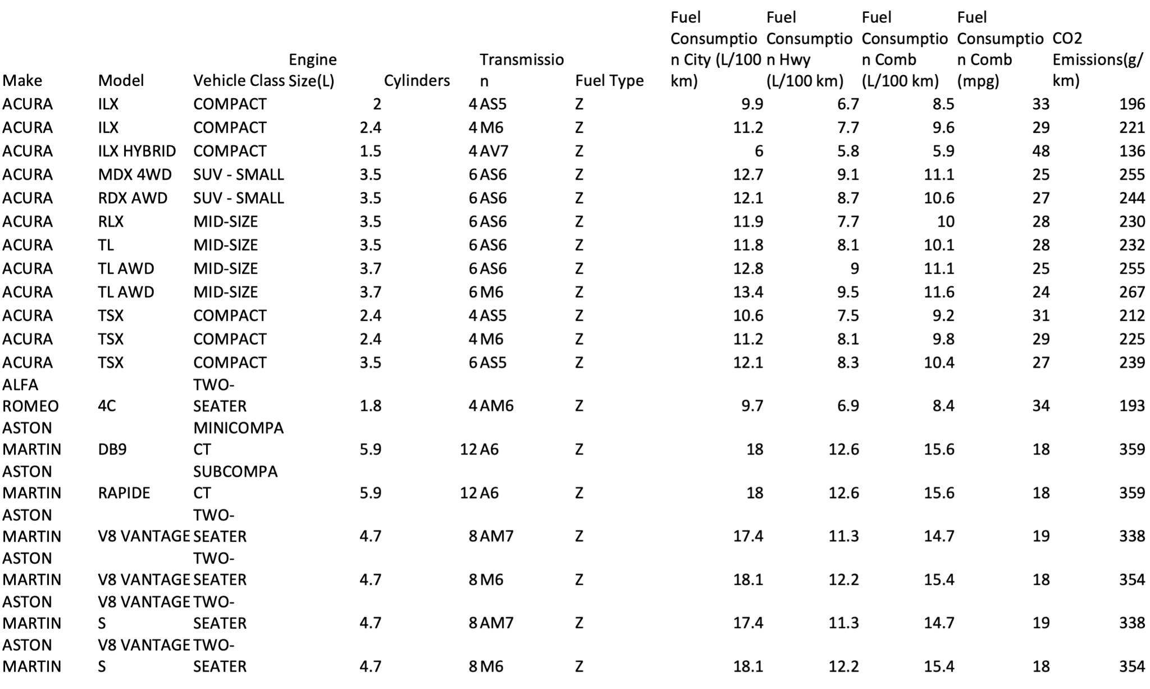
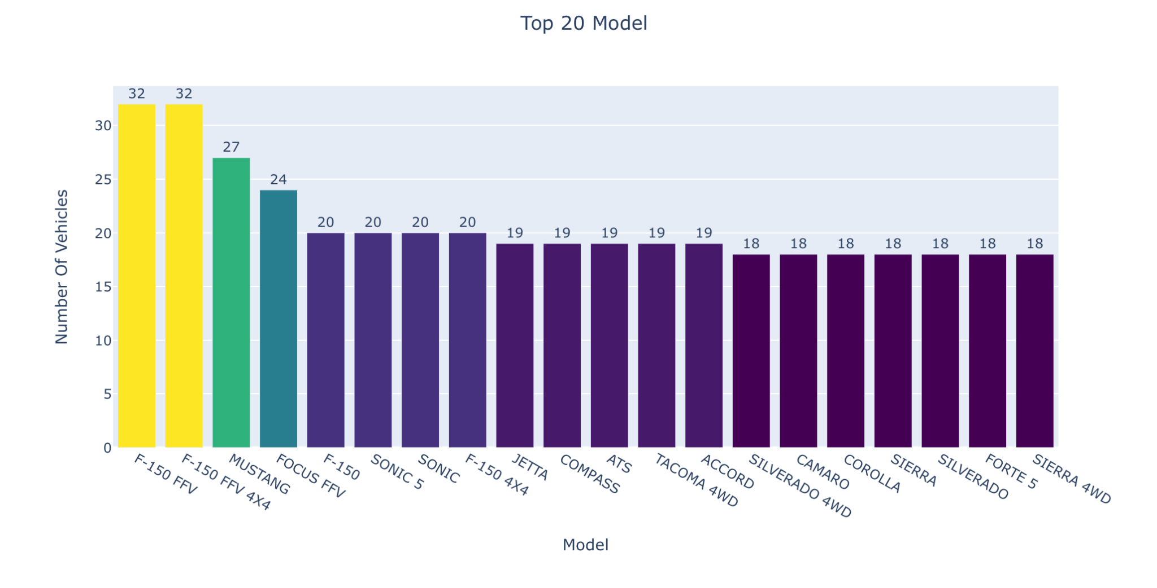 | 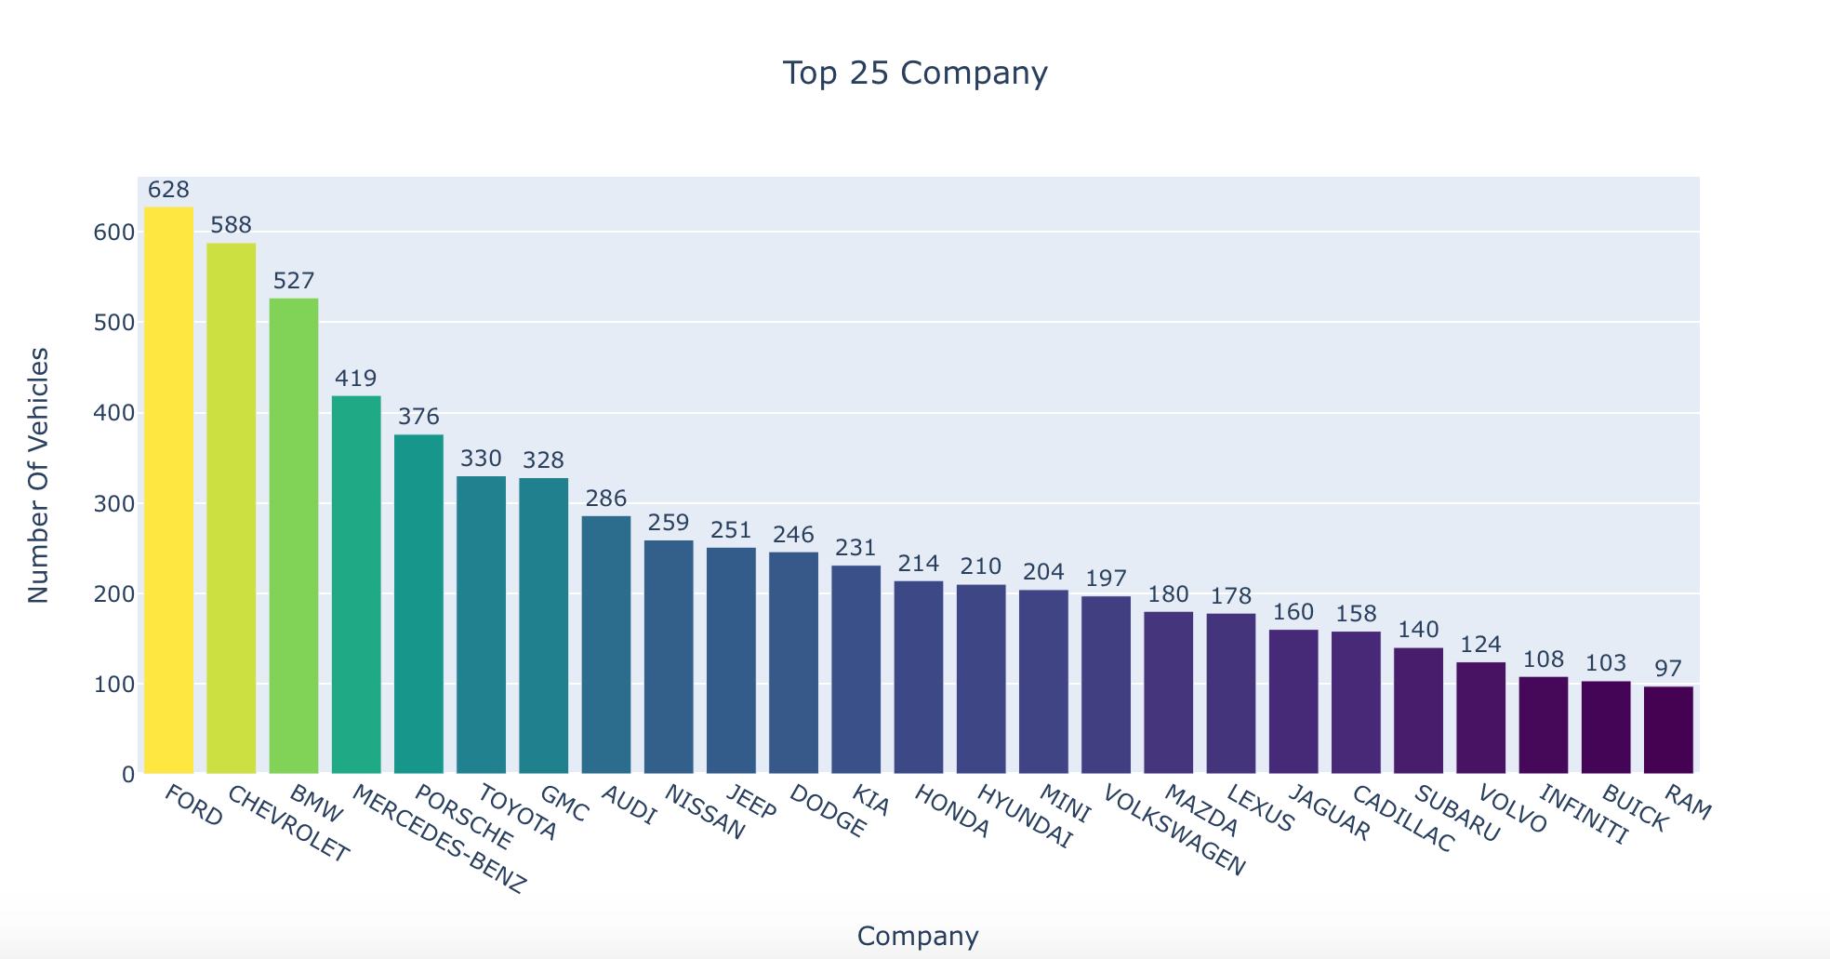
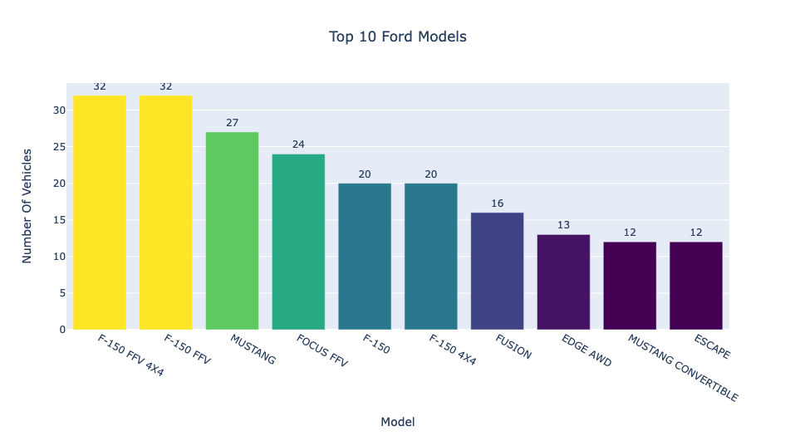 | 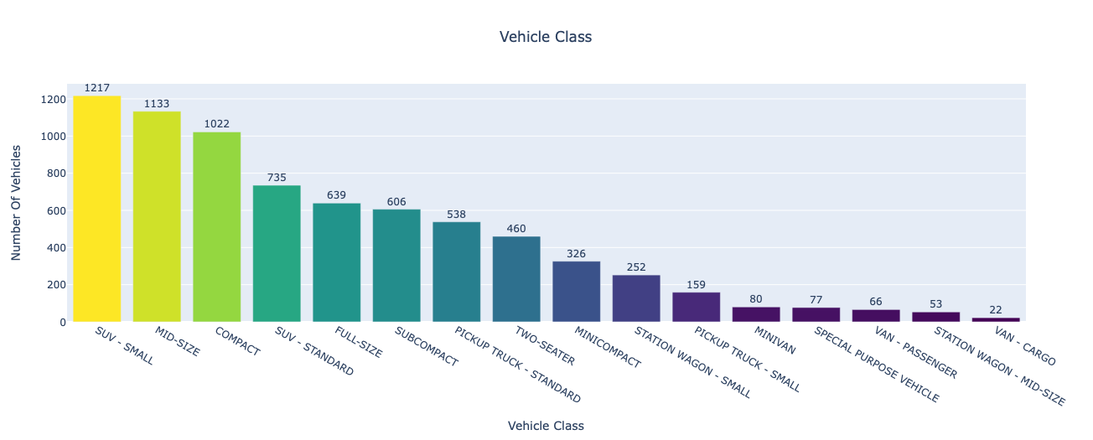
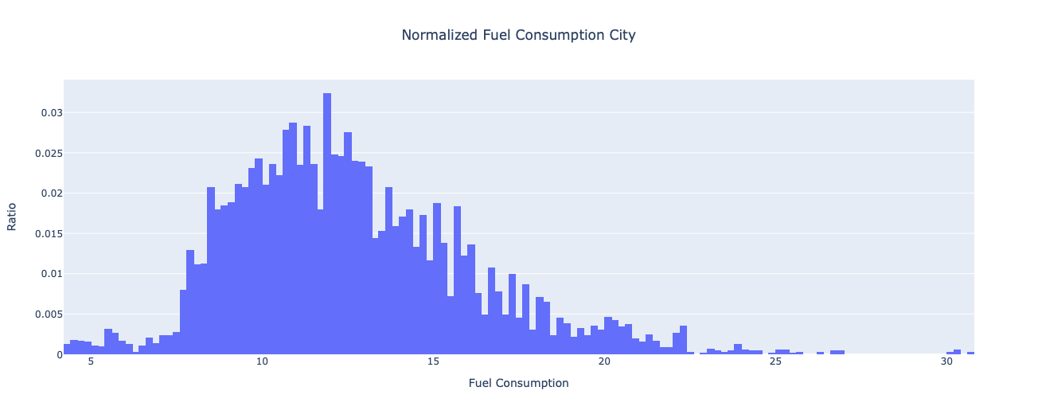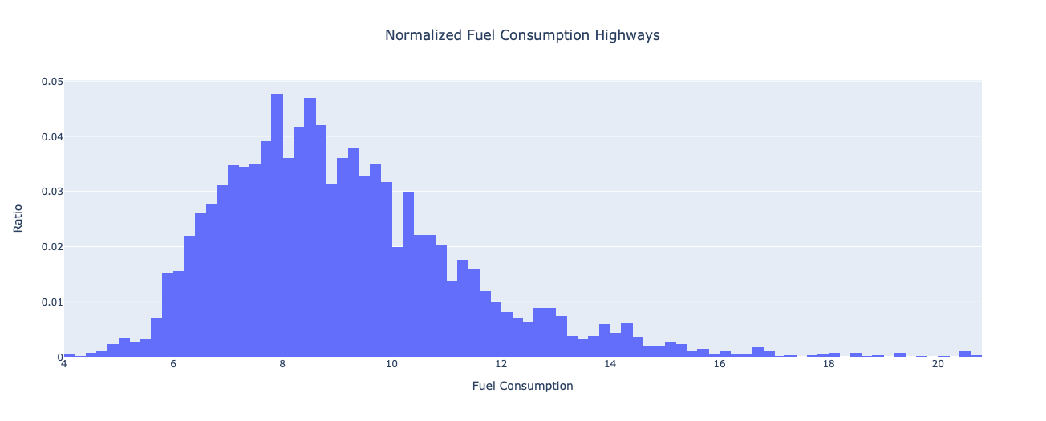
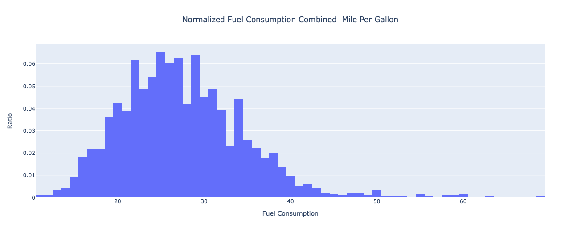 | 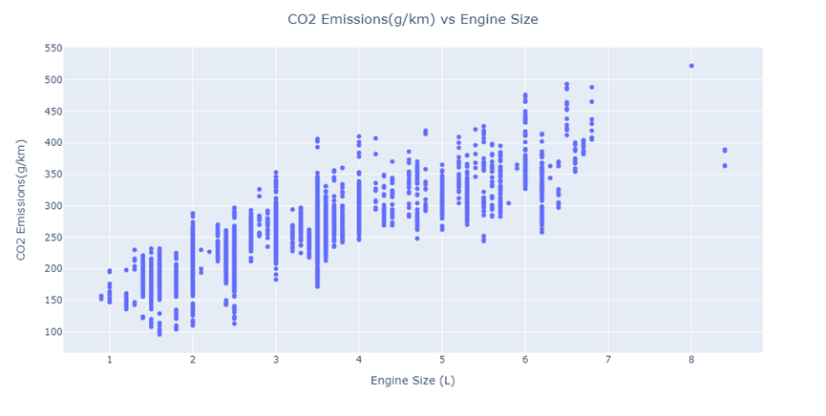
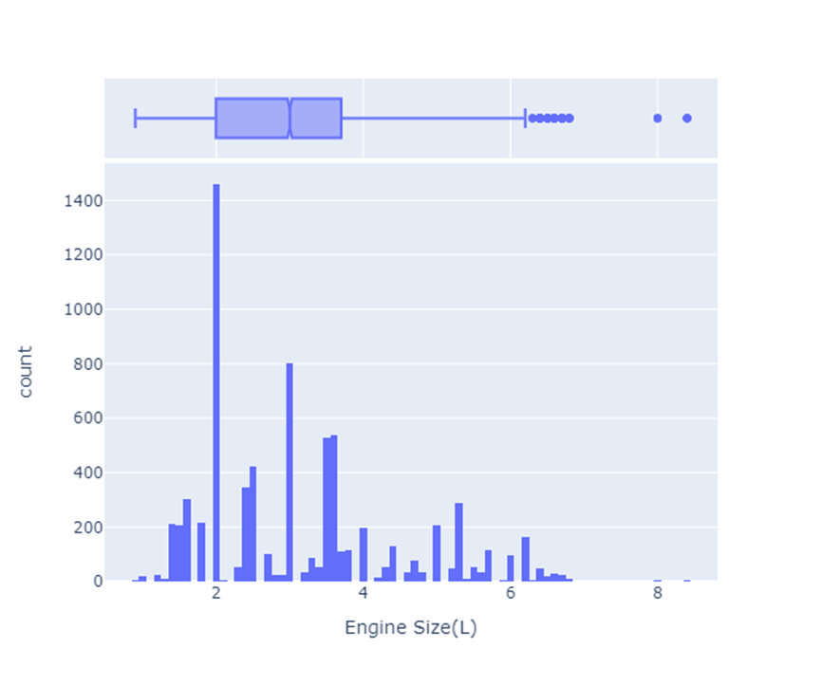 | 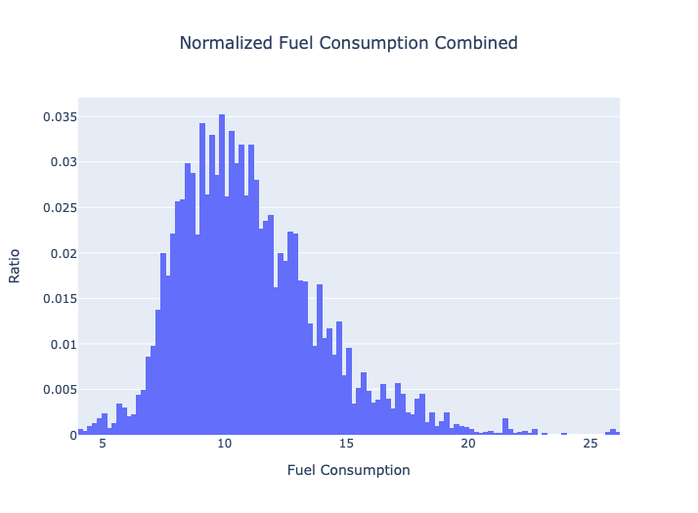
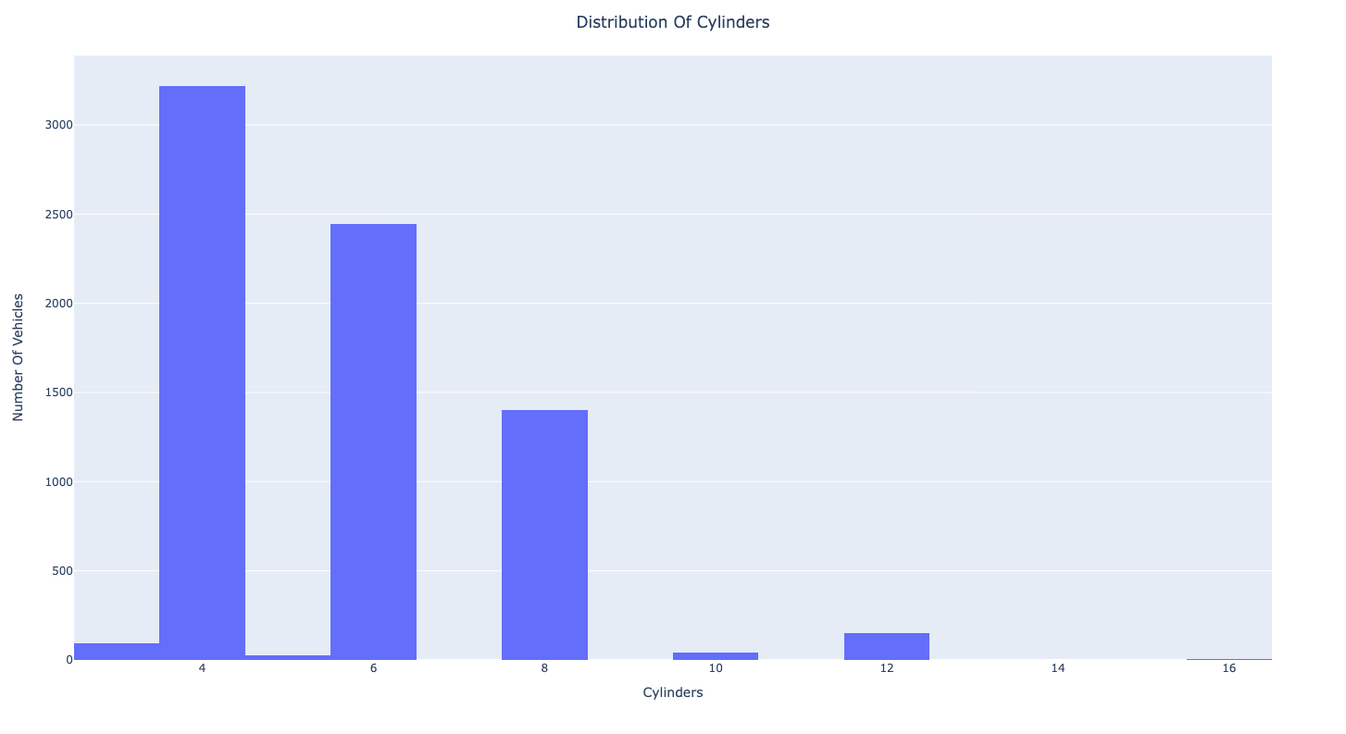 | 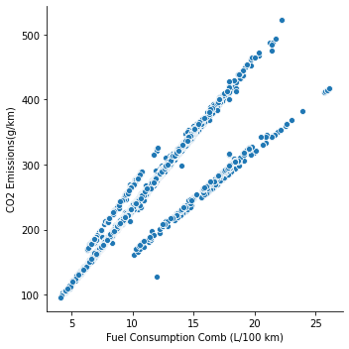
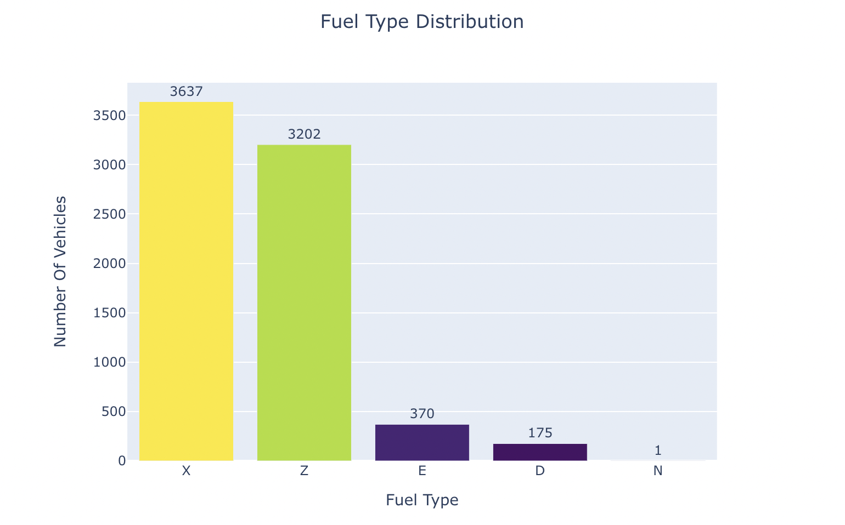 | 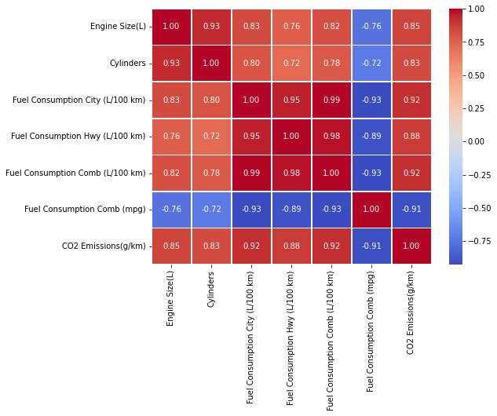

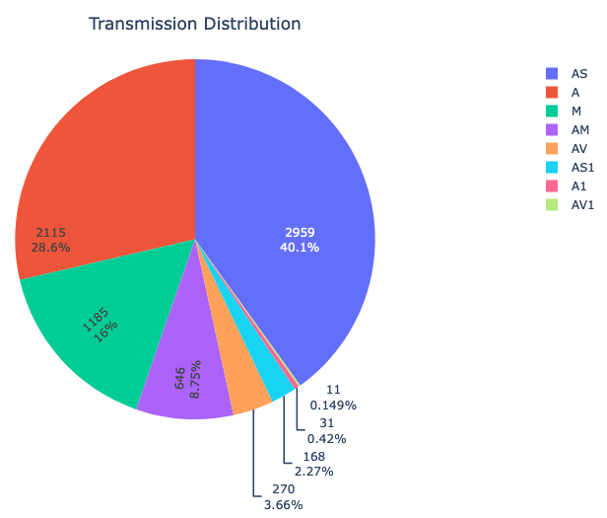 | 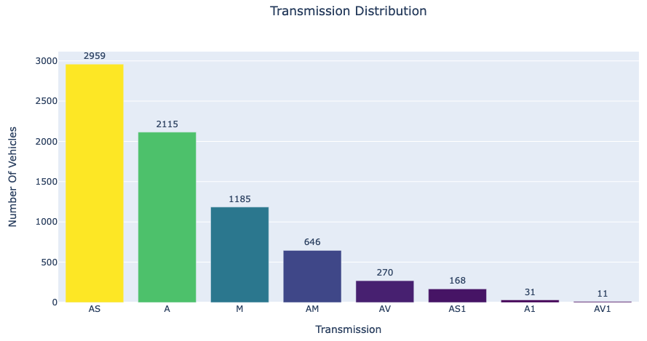
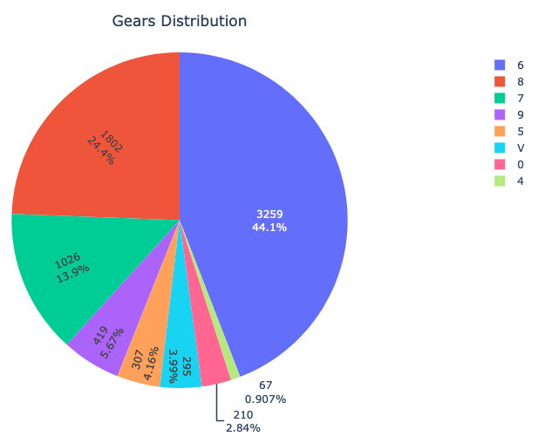 | 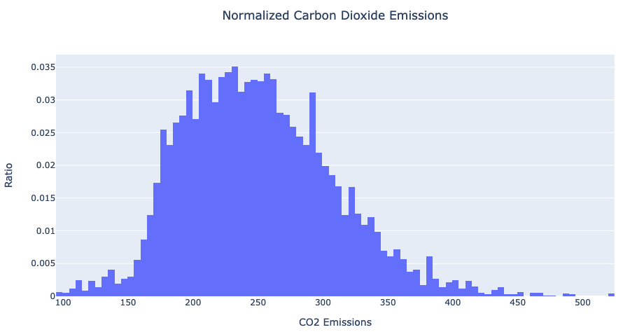
Data Preprocessing
New Dataset
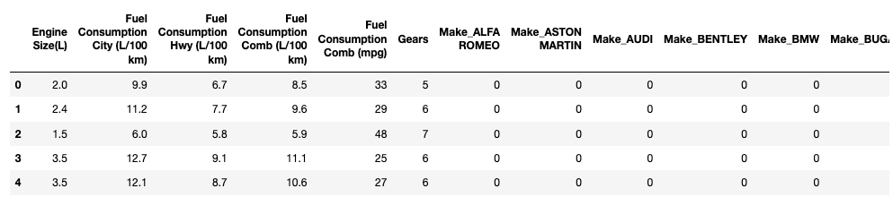

Model Performance
Linear Regression
 | Linear regression | Ridge regression | Lasso regression
Before tuning | 0.9936 | 0.9753 | 0.9935
After tuning | NA | 0.993477 | 0.9935

KNN
 | Default, k=5 | Tuned, k=1 | Tuned with bagging(100 estimators)
RMSE | 11.421831 | 7.598125 | 4.815121
MAPE | 7.228700 | 1.476974 | 1.199203
MAE | 2.992004 | 3.169585 | 2.904765

XGBoost
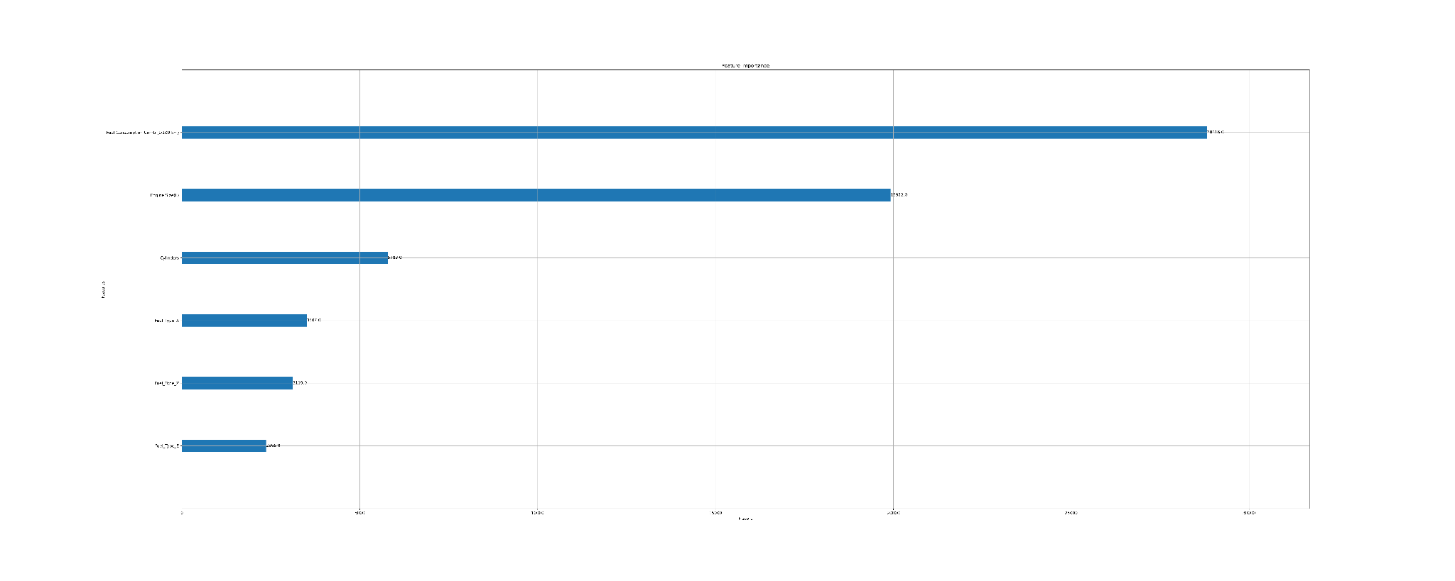

Random Forest
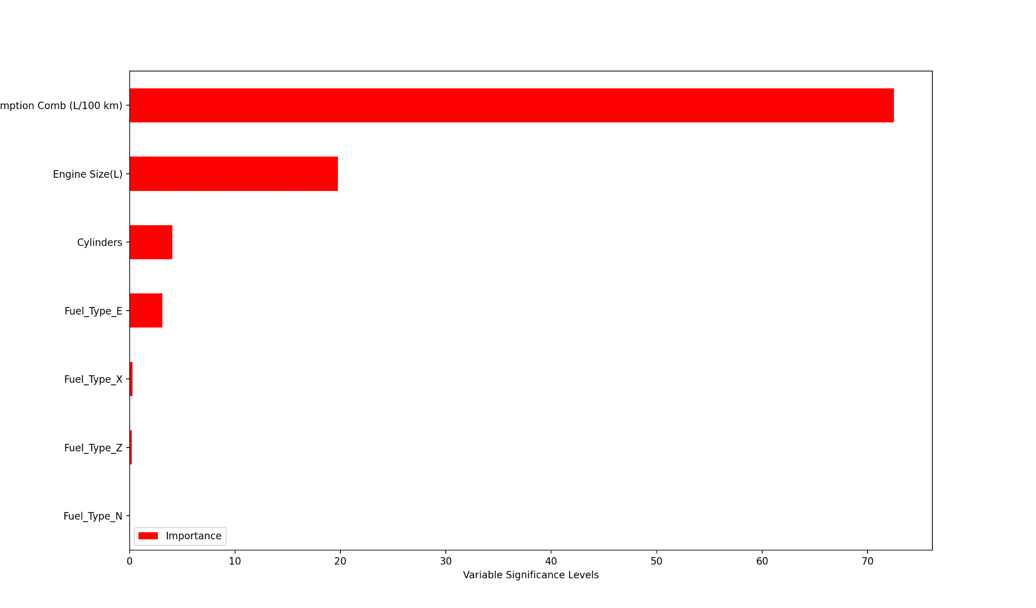
RMSE | MAPE (%) | MAE
14.4933 | 4.0843 | 9.4356
Random forest performance after tuning

